Program meeting advanced river monitoring systems – Italian, European and Swiss experiences and new opportunities – 20 / 21 June 2024

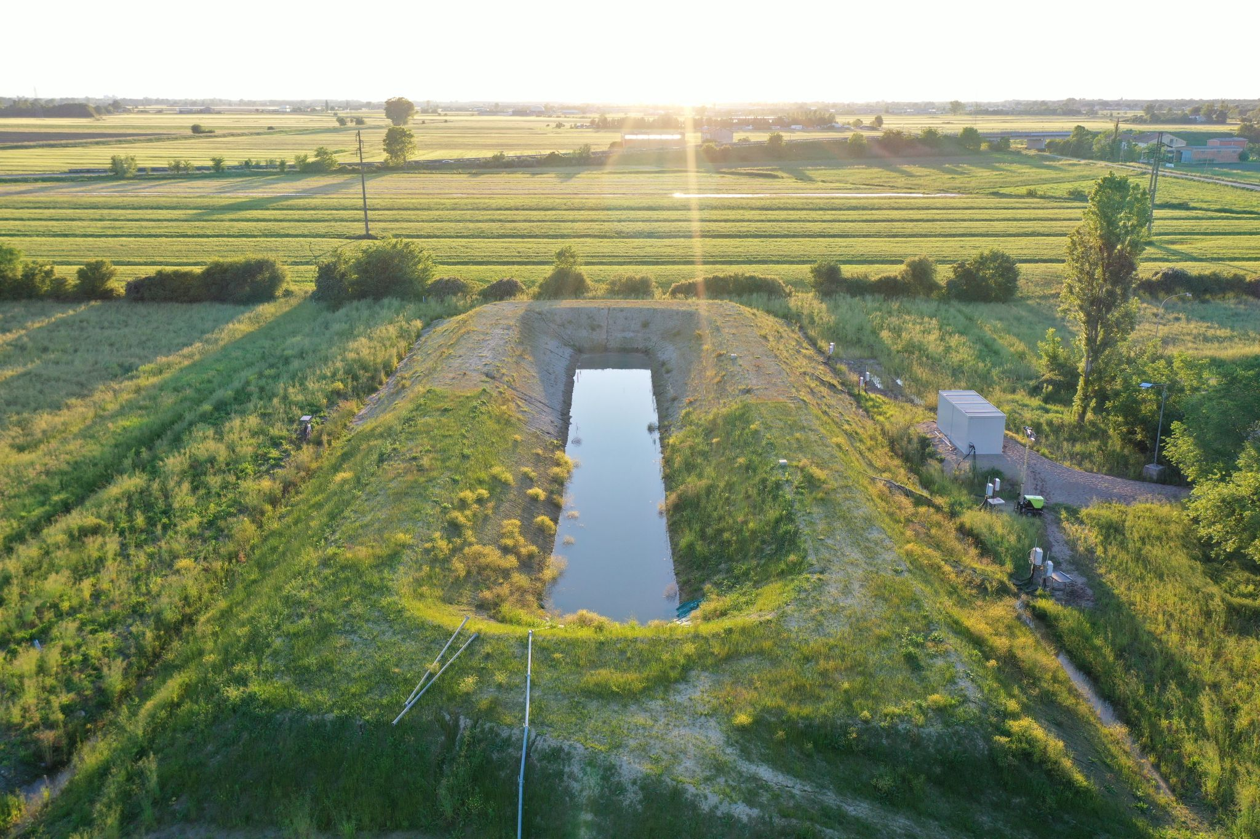

20 June: AIPo Mainquarter (Strada Garibaldi 75 Parma) and Boretto

H 13:00 – 13:30 Trip to Boretto

H 13:30 – 16:00 Visit of AIPo laboratories and experimental levee

21 June: Aula D Università degli studi di Parma Strada Del Prato, 3 Parma
H 09,30 – 09,45 Welcome
H 09,45 - 10,00 Introduction from AIPo director Gianluca Zanichelli
H 10,00 - 10, 30 Agnese Bassi e Michela Marchi (Uni. Bologna) Soil characterization and piezometric monitoring for the management of sand boils .
H 10, 30 – 11,00 Laurence Girolami (INRAE - FRA) Detection of paleo-environments along a diked river to understand the origin and distribution of internal erosion processes - application to the Agly embankment system
H 11,00 – 11,30 Luigi Zanzi (Polit. Milano) Long term monitoring of critical sectors of levees with permanent installations of meteo and ERT stations: the GRETA project.
H 11,30 – 12,00 coffeè break
H 12,00 – 12,30 Roberto Valentino e Roberto Francese (Uni. Parma) Dynamic and static geophysical scanning of earthen levees: advances, limitations and potential correlation with geotechnical parameters. State of the art and possible trends.
H 12,30 – 13,00 Carlo Rabaiotti (OST - CH) Fibradike, a river dikes nervous system

H 13,00 – 14,00 Lunch

H 14,00 – 14,30 Claudio Di Prisco (Polit. Milano) The Argo project: river banks monitoring with fiber optic sensors
H 14,30 – 15,00 Henk van Hemert (Rijkswaterstaat – NL) Some monitoring experiences in NL within a levee managers perspective
H 15,00 – 15,30 Paolo Mazzanti Uni. La Sapienza Roma Photomonitoring solutions for hydrogeological risk assessment.
H 15,30 -16,00 break
H 16,00 – 16,30 Simonetta Cola (Uni. Padova) Monitoraggio delle temperature nel terreno per la comprensione dei processi di filtrazione negli argini
H 16,30 – 17,00 Juan Pablo Aguilar-Lopez (TU Delft – NL) Method for desiccation cracks detection over grass covered dikes based on DTS and Deep learning.
H 17,00 – 17,30 Final discussion and conclusions (Gianluca Zanichelli and Alessandro Rosso AIPO)
Chiarman Luca Crose (AIPO)

